DIS-AM,C-Taino-Tripointer- serpentine motif

Very rare curvilinear serpentine motif which envelops an anthropomorphic figure. The only published example that I have been able to find uses the same curvilinear serpentine motif is in the Museo Arqueologico Regional, Altos de Chavon, Dominican Republic (Bercht, Brodsky, Farmer and Taylor 1997, cat. No. 77, 78).

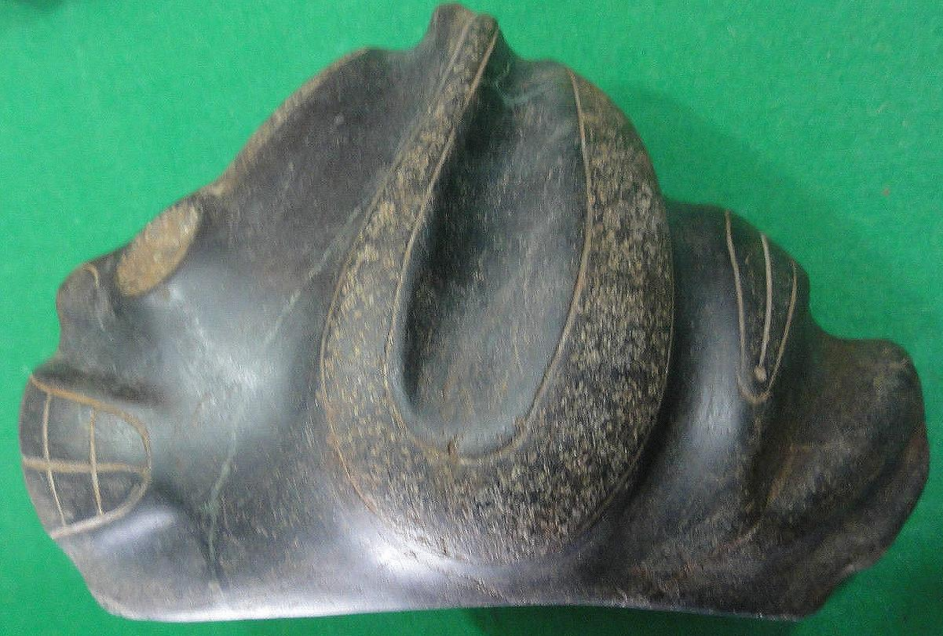

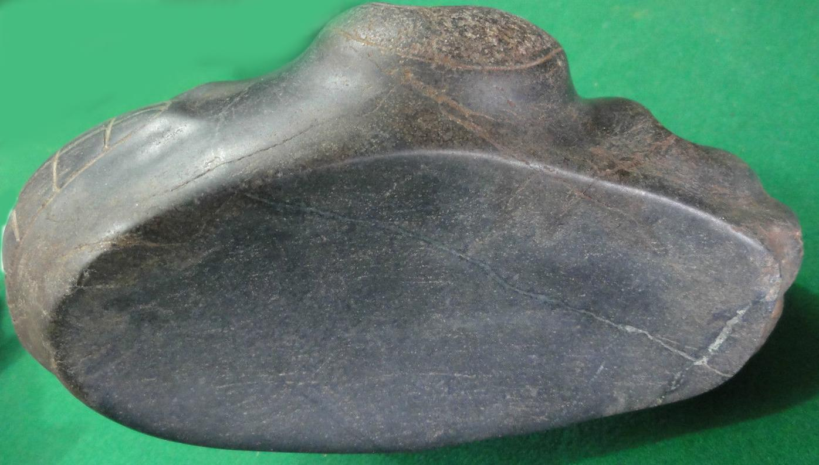

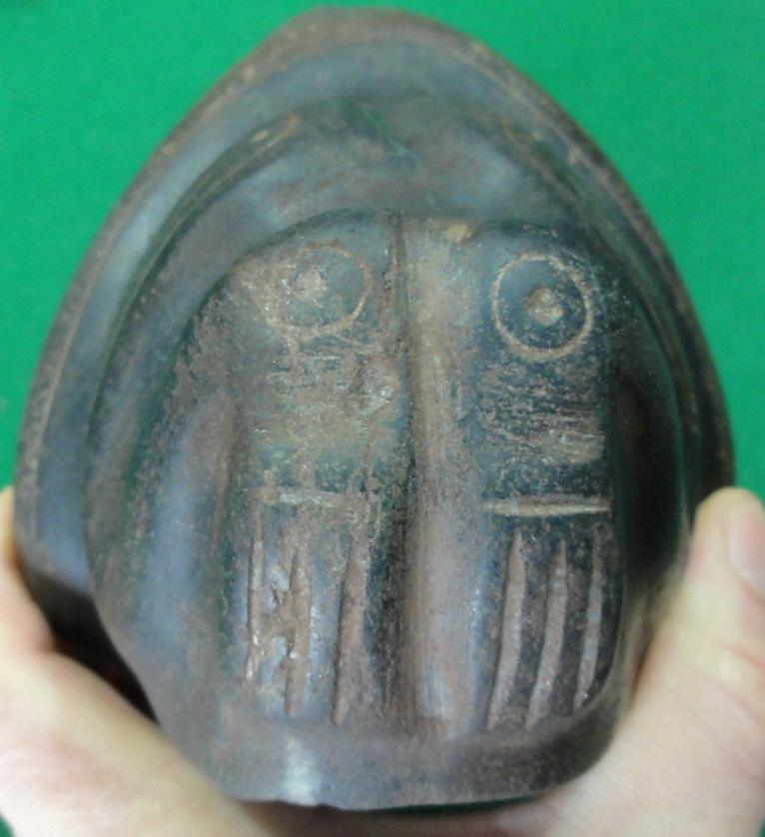 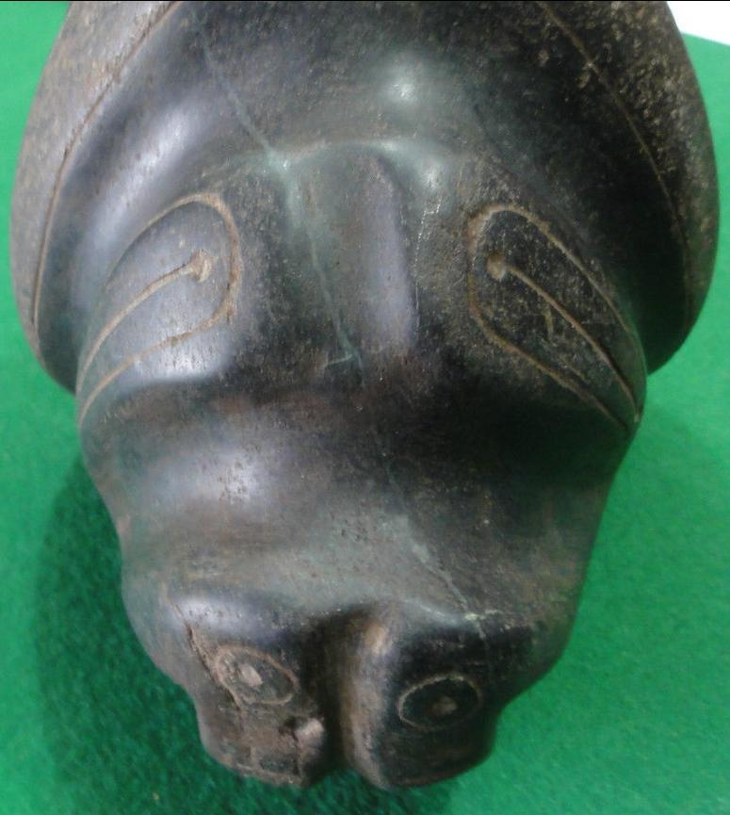 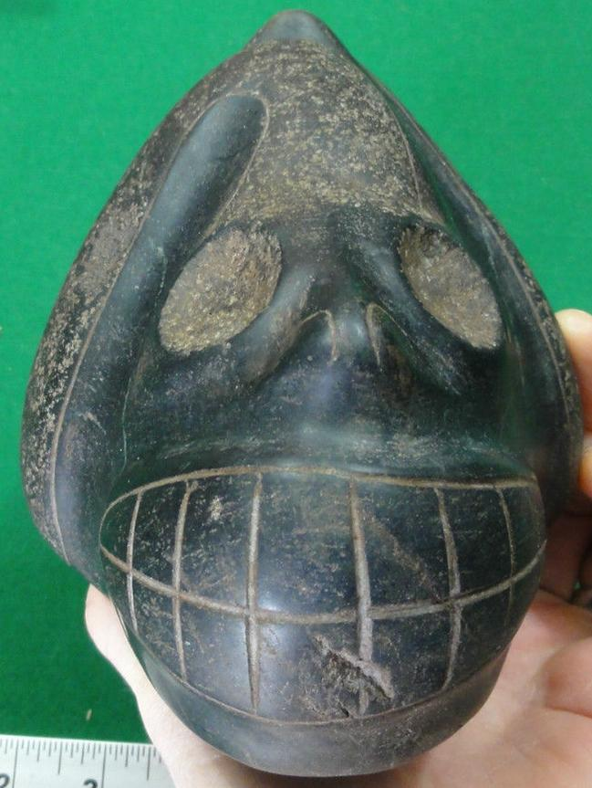 such as [*Psilocybe cubensis*](https://en.wikipedia.org/wiki/Psilocybe_cubensis) z